Project Manager Meetings
Project Manager Meetings
Members:
Summary of PM/DPM Meeting: 09/02/26
Summary of PM/DPM Meeting: 16/02/26
Summary of PM/DPM Meeting: 23/02/26

Members:
Elizabeth - SA - Team A - Pm
Humd - SA - Team A - DPm
Rohit - CA - Team B- Pm
Hetal - CA - Team B - DPm
Furqan - PU - Team C - Pm
James - PU - Team C - DPm

Summary of PM/DPM Meeting: 09/02/26

What was discussed:
- Implementing REST API
- All three teams are using Java
- Docker container to connect Java and connect with the desktop front-end
- Finish three days in advance (12 pm 24th of Feb)
- Team A and B will be using a desktop frontend (JSwing or FX) whilst Team C will be developing a locally-hosted web frontend (Electron) connected to a backend.
- Every team is on Analysis stage
- Agreed to have one component diagram

Questions to discuss next time:
- Docker container running locally - on desktop (no internet needed)
  - Will MondoDB be suitable? MySQL?
- SpringBoot is pretty heavy for the prototype. Should we consider changing from java to python and use Flask?

Questions for consultant:
- Ask if we should use web page or the desktop application
  - can do both
  - SA-desktop application
- Docker container to connect Java and connect with the desktop front-end
no interaction required in the report, what is public orders

Actions:
- Make Docker containers to run their subsystems (James (Team C), (Team A), (Team B).

Summary of PM/DPM Meeting: 16/02/26

what was discussed:
- Methods from PU: sendEmails() , updateStatus()
- Methods from PU to CA: processPayment()
- Methods from CA to PU: sendUpdatedStock(), getStock()
- Methods from SA: orderHistory()
- Methods from SA to CA: receiveLogin(), sendOrder(), creditLimit(), stockRequest(ID), balance(),
- Methods from SA to PU: catalogue()
Method Directions:
PU -> CA
CA <-> SA
SA -> CA

Summary of PM/DPM Meeting: 23/02/26

what was discussed:
- CA needs to give updated stock availability to PU
- Rohit to split component diagram into 3 interface classes
- Rohit to make component diagram consistent for all teams
james: should we put variables/types in to help us later?

CA current component diagram:

Summary of PM/DPM Meeting: 01/04/26

what was discussed:
- Displayed the code for interaction between subsystems
- Discussed how we will connect via Rest API
- On the 12th the code should be ready and fully functional
james: should we put variables/types in to help us later?

CA current component diagram:

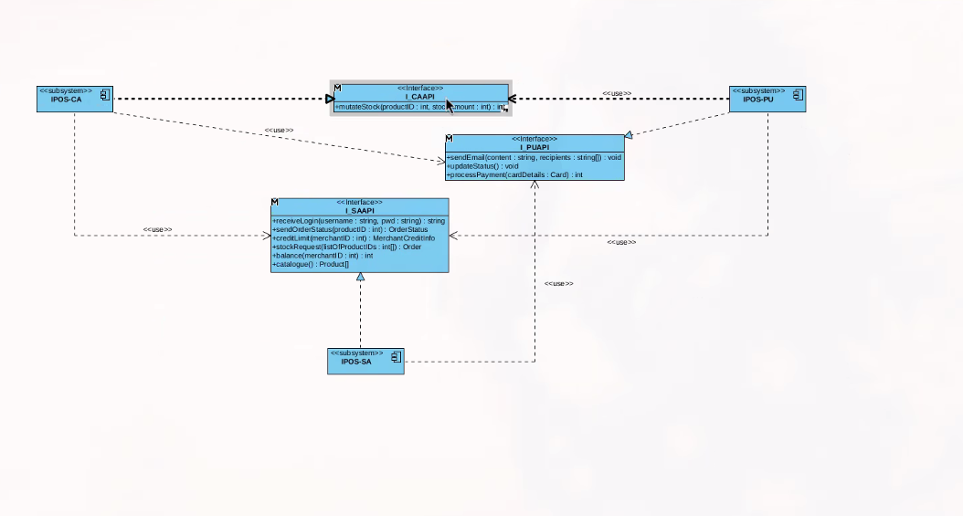
SA current component diagram:

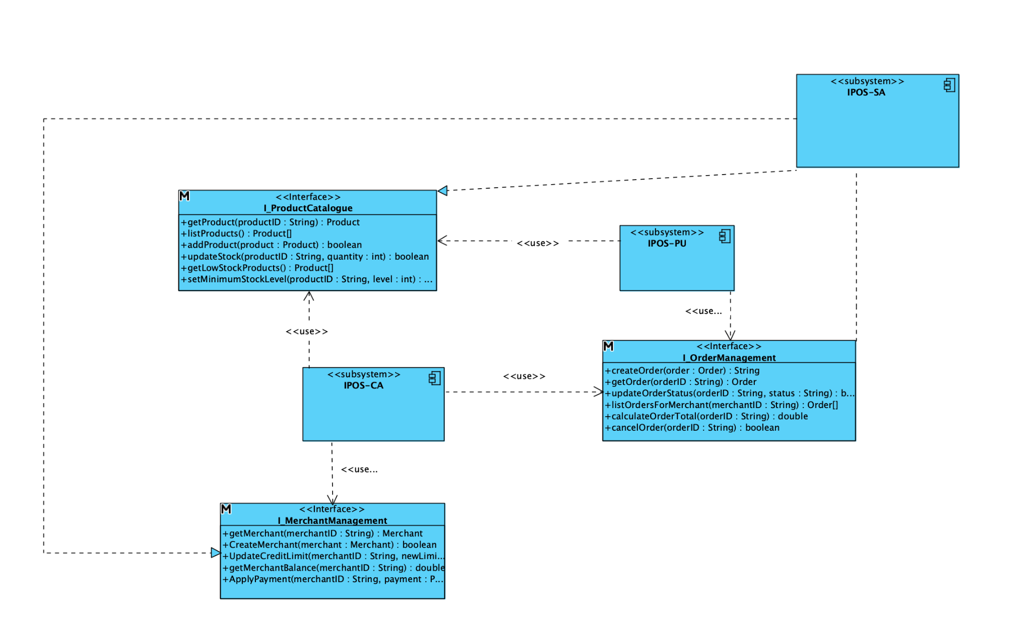

PU Current Component Diagram:
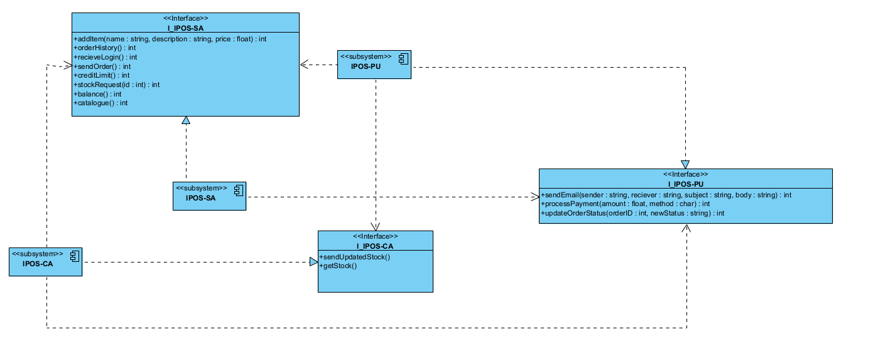
Clarifying note: The receiver parameter of sendEmail() should be a string array, not a string.

Summary of meeting 09/03/2026
What was covered:
- programming deadlines
  - SA- no set deadlines yet (but still ahead of time: estimated finish early april)
  - CA- programming- 1st April, a week and a half to put everything together and deploy- April 12th
  - PU-no set deadlines yet( but best estimate of a week) or 7th april
    - Stripe-payment processor
- weekly programmer meetings-ONLY THE PROGRAMMERS WORKING ON PACKAGES THAT HAVE OTHER SUBSYSTEM INTERACTIONS
  - time to be confirmed by this wednesday
- look at the brief / reading week lecture for a deeper understanding on the new deliverable
- No more PM/DPM meetings unless needed

Programmer responsibilities;
IPOS-SA:
Nikki (+44 7368 317017) - IPOS-SA-reviews code and database part
Nizar (+44 7832 222474) - IPOS-SA- implementation and sequels
Afifa (+44 7427 831501) - IPOS-SA- testing part

IPOS-CA:
Rohit (+44 7882 007698) - IPOS-CA-CUST, IPOS-CA-SALES
Hetal (+44 7818 891974) - IPOS-CA-STOCK, IPOS-CA-USER
Ahmed (+44 7943 577377) - IPOS-CA-ORD
Wasil (+44 7375 960383) -IPOS-CA-TEMPLATES, IPOS-CA-RPT

IPOS-PU:
james (+44 7398 986679) - IPOS-PU-COMMS
dawud (+44 7756 056436) + haris(+44 7432 415852) - IPOS-PU-SALES
bahja(+44 7438 114650) - IPOS-PU-MEMBERS
huzefa(+44 7538 492669) - IPOS-PU-PRM
faisal(+973 3403 0303) - IPOS-PU-RPT
furqan (+44 7850 256110) - IPOS-PU-GUI

